<link href="{{ asset('css/app.css') }}" rel="stylesheet" type="text/css" >

<script type="text/javascript" src="{{ asset('js/custom.js') }}"></script>

{{ asset('img/photo.jpg'); }}

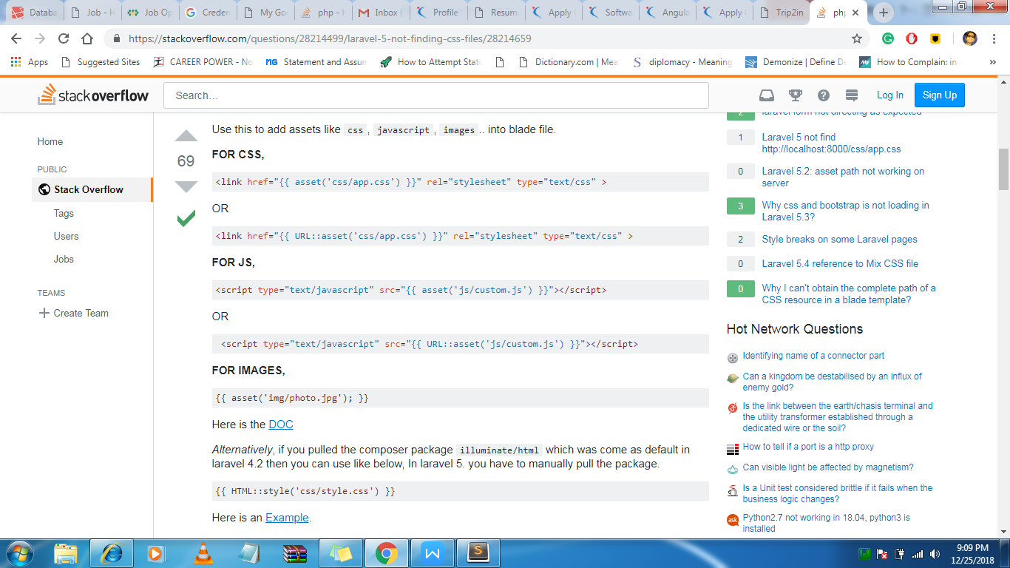

Php artisan serve

Php artisan route:link

Php artisan migrate

Php artisan make :migration add_user_id_to_users

**Making the controller from cmd**

php artisan make:controller PostController --resource

**Making the Model**

php artisan make: model User -m

php artisan route:list

$json = file_get_contents($google_url);

$jsonArr = json_decode($json);

$lat = $jsonArr->{'results'}[0]->{'geometry'}->{'bounds'}->{'northeast'}->{'lat'};

$lng = $jsonArr->{'results'}[0]->{'geometry'}->{'bounds'}->{'northeast'}->{'lng'};

<https://maps.googleapis.com/maps/api/geocode/json?address=$address&sensor=false&key>

<img src="{{asset('/imgs/') }}/{{$destination->image_name}}"